Machine Learning Project Report
Project Title: A Data-Driven Skill Pathway for Student Career Readiness
Team Members:
- Barath Kumar S (24BIT011)
- Kishor S (24BIT051)

1. Project Overview & Dataset Description
The objective of this project is to bridge the gap between academic learning and career outcomes. By integrating multiple datasets covering student demographics, academic performance (CGPA, backlogs), technical skills (coding, core CS subjects), and financial outcomes (LPA, stipends), we aim to create a predictive model that recommends specific skill pathways for career success.

Dataset Integration
Since the data is spread across 13 distinct Kaggle datasets, our primary task is Data Synthesis. We are categorizing the data into three functional clusters:
- Academic & Demographic Data: Covers GPA, 10th/12th percentages, age, and major.
- Skill & Competency Data: Specific focus on "Computer Science Students Strength" and "Skillset Analysis" (OOP, Algorithms, DBMS, etc.).
- Outcome Data: Placement status, starting salaries, and mid-career salary growth.

2. Variable Identification
To build an effective model, we categorize the combined features as follows:

Independent Variables (Predictors)
- Academic Metrics: CGPA, 10th/12th Grade percentages, History of Backlogs, Attendance Rate.
- Technical Proficiencies: Grades/Scores in Core subjects (Data Structures, Algorithms, DBMS, ML, OOP), Total Problems Solved.
- Professional Exposure: Number of Internships, Projects Completed, Extra-Curricular Score.
- Soft Skills: Communication Skills, IQ.

Dependent Variables (Targets)
- Placement Outcome: Binary classification (Placed or Not).
- Financial Outcome: Continuous value (Offered Salary/LPA).
- Career Path: Categorical (Future Career/Interested Domain).

3. Data Preprocessing Requirements
Before the datasets can be used for training, the following preprocessing steps are essential:

A. Data Cleaning
- Handling Missing Values: Use Mean/Median Imputation for continuous variables (like CGPA) and Mode Imputation for categorical variables (like Major or Gender).
- Deduplication: Removing redundant student records across overlapping datasets using IDs or demographic matches.
- Outlier Detection: Identifying and handling anomalies in salary data (LPA) using the IQR (Interquartile Range) method to prevent model skewness.

B. Feature Engineering & Transformation
- Categorical Encoding: * One-Hot Encoding: For nominal data like Stream, Major, and City.
  - Label Encoding: For ordinal data like Year of Study or Academic Performance (Low, Medium, High).
- Feature Aggregation: Creating a "Technical Strength Score" by averaging grades across core CS subjects (Data Structures, Algorithms, OS).

4. Scaling and Normalization
Since our features use different units (CGPA is 0–10, Percentages are 0–100, Salaries are in Lakhs), scaling is mandatory to ensure the model doesn't give undue weight to larger numbers.
- Min-Max Scaling (Normalization): We will apply this to features with fixed boundaries, like CGPA and Percentages, to bring them into a range of [0,1].
​​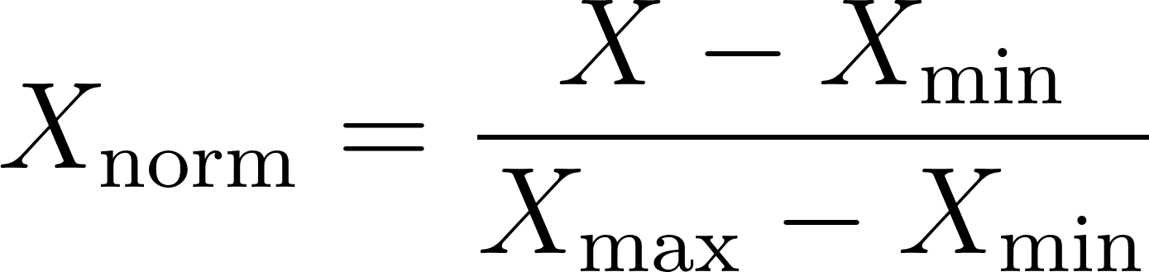
- Standardization (Z-score Normalization): For IQ scores and Salaries, which may follow a Gaussian distribution, we will use Standardization to center the mean at 0 with a standard deviation of 1.
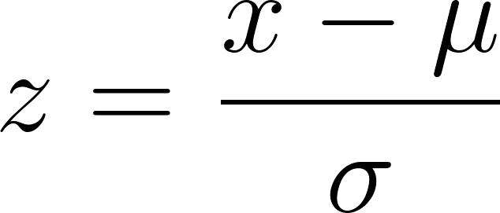

5. Proposed Model Workflow
- Phase 1: Merge datasets based on common attributes (e.g., Major, GPA).
- Phase 2: Preprocess and Scale (as detailed above).
- Phase 3: Feature Selection using Correlation Matrices to identify which skills (e.g., Algorithms vs. Extra-curriculars) have the highest impact on Salary.
- Phase 4: Train Classification (for Placement) and Regression (for Salary) models.

